**NANDHA ENGINEERING COLLEGE**

**(AutonomousInstitution)**

Erode-638 052

 **DATA VISUALISATION COURSE**

**IV–Semester**

**DEPARTMENT OF ARTIFICIAL INTELLIGENCE AND**

**DATASCIENCE**

**NAME :SRIPRIYA JS**

**BRANCH :B.TECH AI & DS**

**YEAR :II**

**TABLEAU**

* **Data Visualization**: Converts raw data into interactive, visual insights like charts, graphs, and maps.
* **User-Friendly Interface**: Offers a drag-and-drop interface for easy creation of reports and dashboards.
* **Real-Time Analytics**: Supports real-time data analysis for quick decision-making.
* **Wide Data Connectivity**: Connects to various data sources, including databases, spreadsheets, and cloud services.
* **Collaboration and Sharing**: Enables users to share and collaborate on interactive dashboards for team decision-making.

**PROJECT TITLE:**

“TUTORING WEBSITE DATA USING TABLEAU”

**PROJECT OVERVIEW:**

This project focuses on analyzing data from a tutoring website using **Tableau**, a powerful data visualization tool. The goal is to uncover meaningful insights into user activity, tutor performance, subject popularity, and overall platform usage. By transforming raw data into interactive visual dashboards, the project aims to support data-driven decision-making for platform improvement and user engagement.

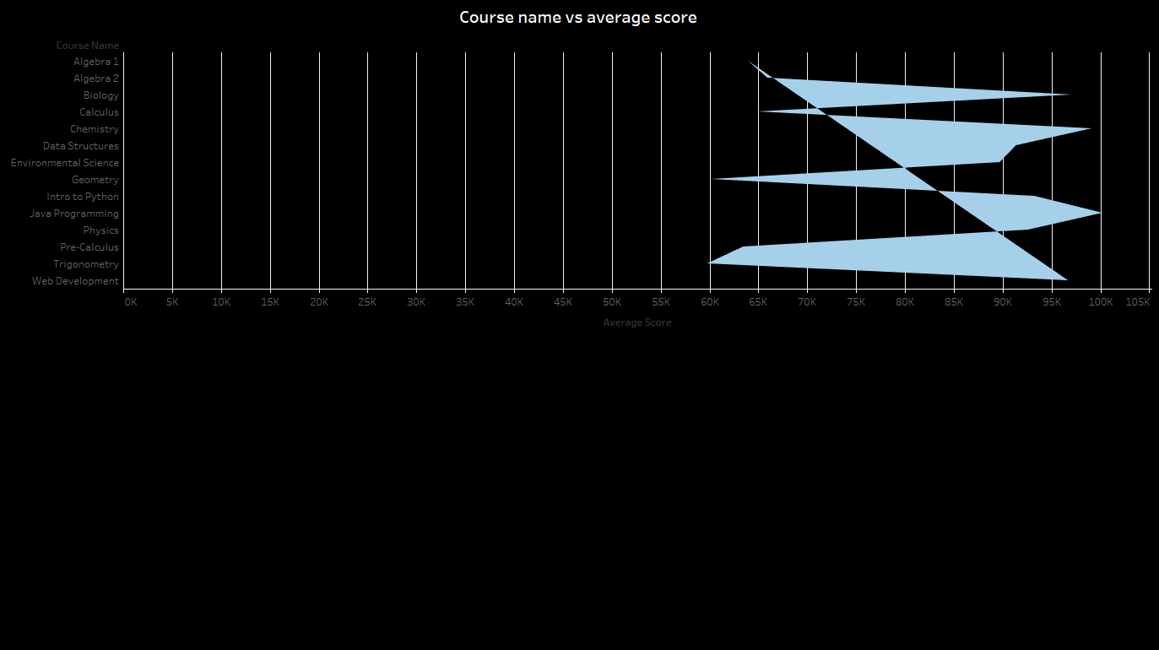

* The slide shows a horizontal area chart comparing different courses based on their average scores.
* Courses listed include Algebra, Calculus, Biology, Programming, and more.
* The x-axis represents the average scores, but the labeling (in thousands) seems incorrect for the context.
* Light blue shaded areas highlight the magnitude of scores for each course against a dark background.
* The chart visually identifies which courses have the highest and lowest average scores at a glance.

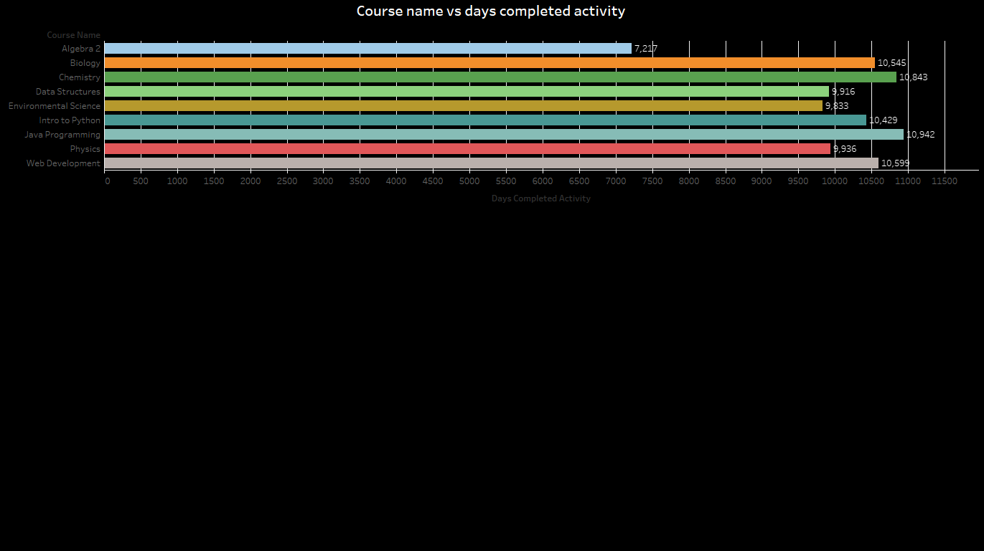

* The slide features a horizontal bar chart comparing different courses by the number of days students completed activities.
* Course names like Algebra 2, Biology, Chemistry, and programming courses are listed along the y-axis.
* The x-axis represents the number of days activities were completed, ranging roughly from 7,000 to 11,000 days.
* Biology and Chemistry show the highest number of completed activity days, crossing 10,000 days.
* Algebra 2 has the lowest recorded days completed, at around 7,217 days.
* Each course bar is color-coded, improving visual distinction between courses.

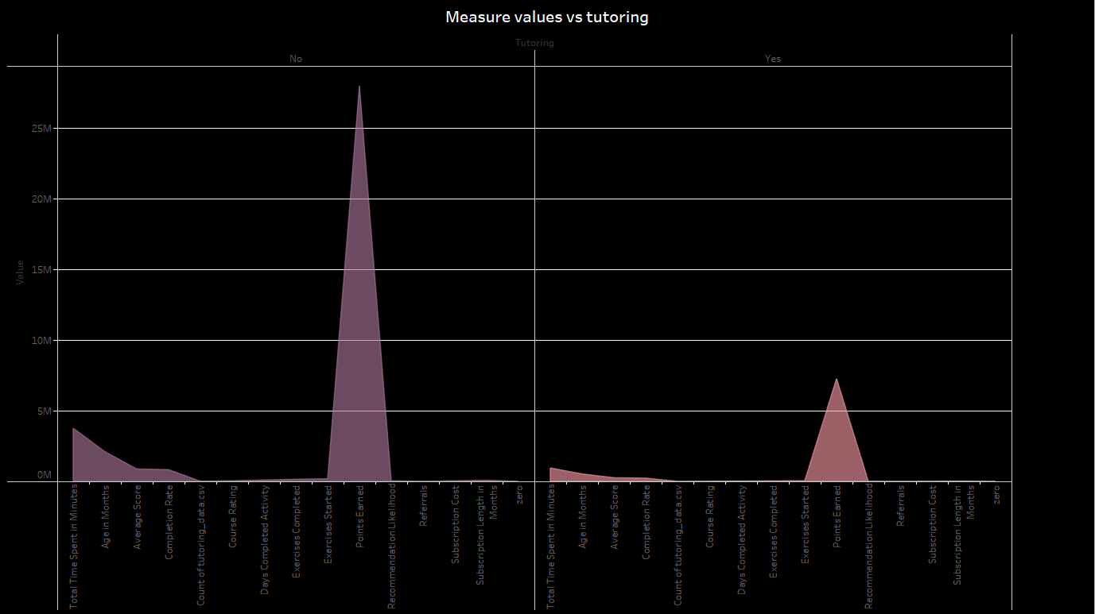

* The slide displays a dual area chart comparing various measure values for students **with** and **without** tutoring.
* The x-axis lists different educational and engagement measures like "Total Time Spent," "Average Score," "Points Earned," etc.
* The y-axis represents the numerical value for each measure, with a noticeable difference in scale between groups.
* Students **without tutoring** show a significantly higher peak, especially in "Points Earned," compared to students **with tutoring**.

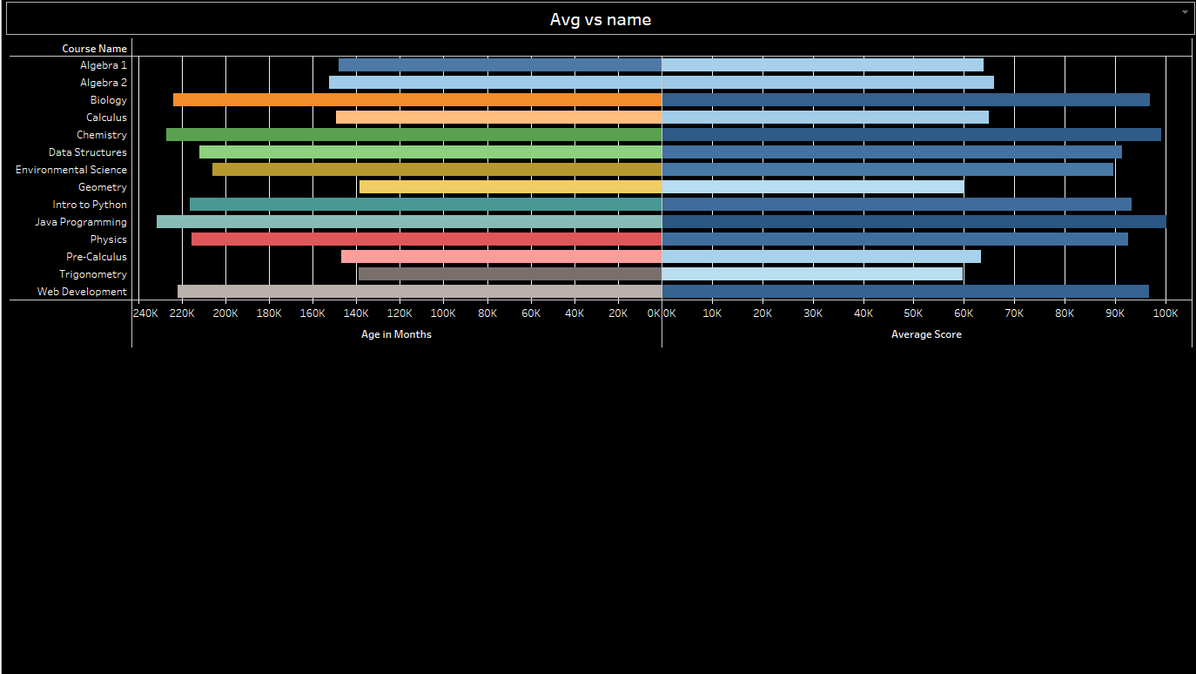

* The chart compares **Age in Months** and **Average Score** across various courses like Algebra, Biology, Programming, etc.
* Each course has two corresponding bars: one showing age (left) and one showing average score (right).
* Most students enrolled are around **140K–240K months** old (around **11–20 years** when converted properly).
* **Web Development** and **Intro to Python** show some of the **highest average scores** nearing **100K** units.
* **Algebra 1** and **Pre-Calculus** have relatively lower average scores compared to others.
* The layout uses a dark background with distinct color coding for easy differentiation between courses.

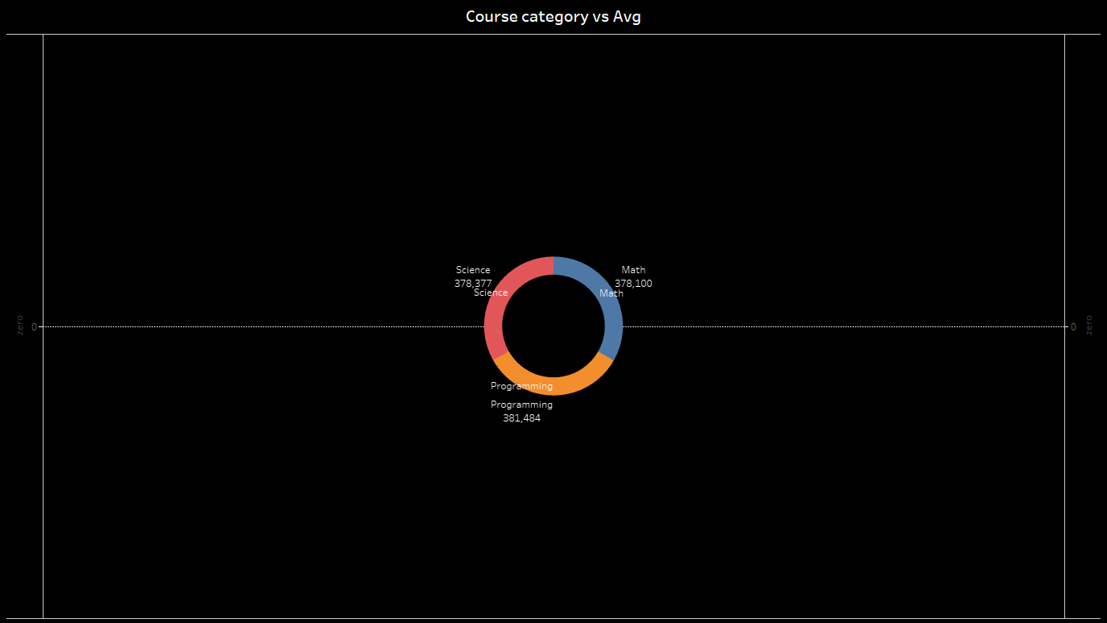

* The slide shows a title introducing the comparison of course categories and their average values.
* The slide shows a donut chart visualizing the average metrics for Science, Math, and Programming categories.
* The slide highlights that Programming has the highest average value among the three categories.
* The slide emphasizes that all course categories have very close average values.
* The slide uses a dark theme with clean and minimalistic design elements to enhance readability.

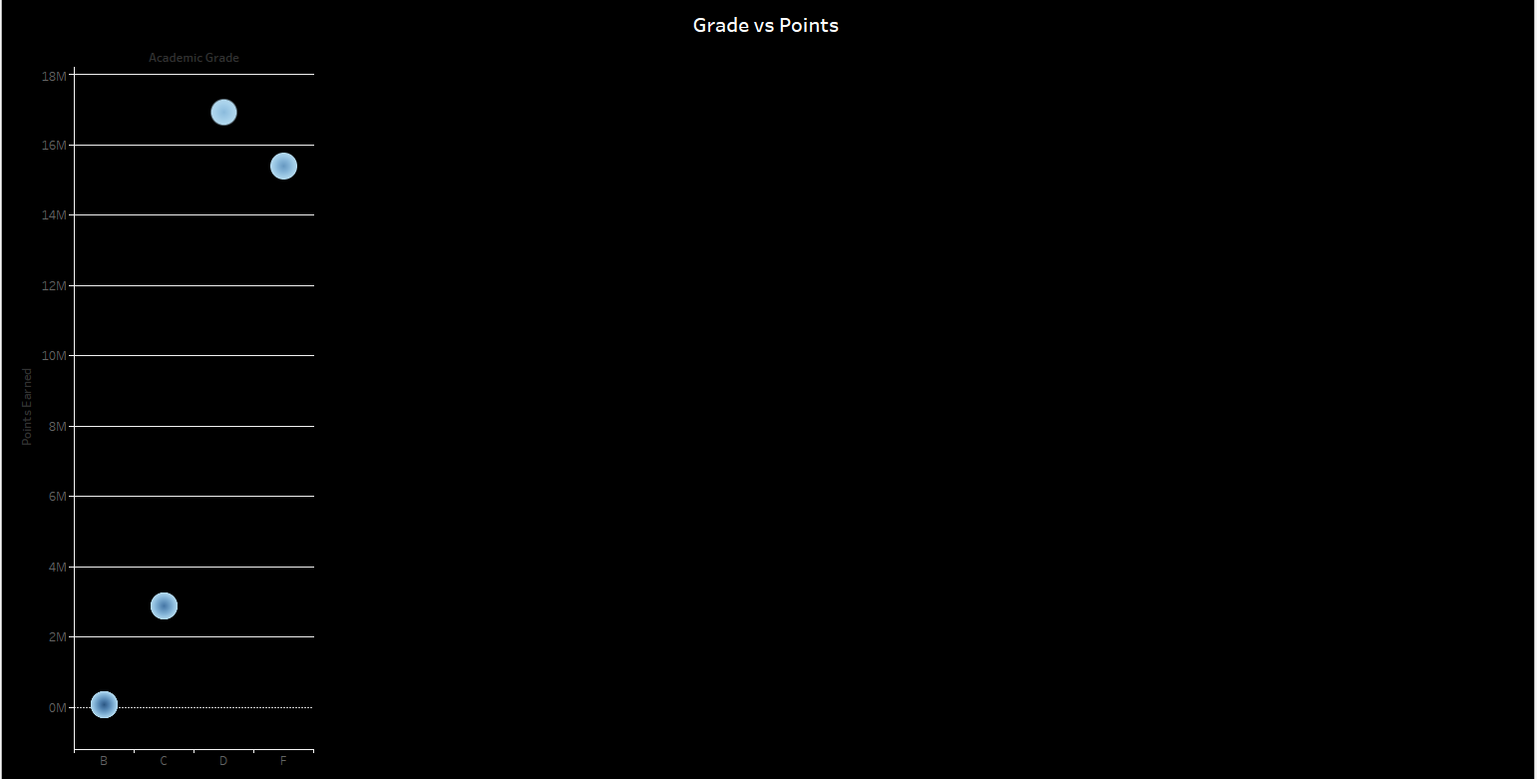

* • The slide shows a title introducing the comparison of academic grades and the points earned.
* • The slide shows a bubble chart plotting different grades (B, C, D, F) against total points.
* • The slide highlights that grades A and B have significantly higher points compared to lower grades.
* • The slide shows a clear drop in points earned as the grades move from B to F.
* • The slide uses a dark theme with bright blue bubbles to enhance visibility and focus.

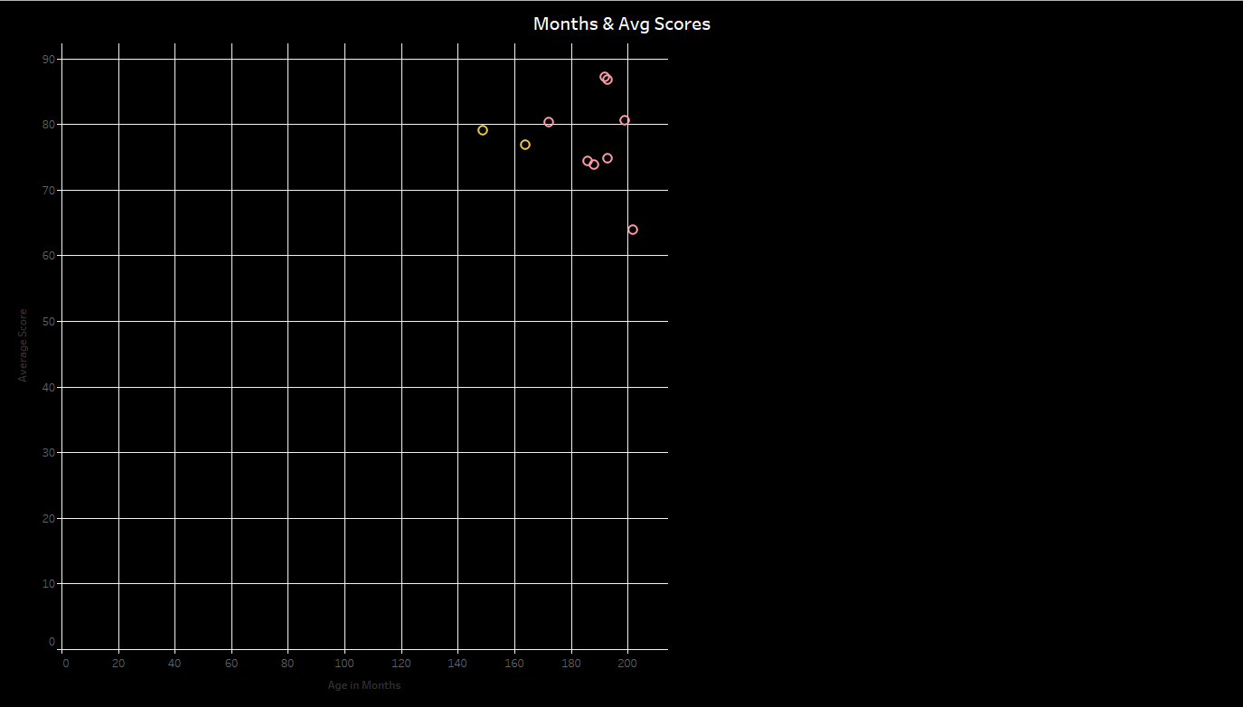

• The slide shows a title introducing the relationship between age in months and average scores.

• The slide shows a scatter plot with points representing different ages and their corresponding average scores.

• The slide highlights that most average scores range between 70 and 90.

• The slide shows that higher ages tend to correlate with slightly higher average scores.

• The slide uses a dark background with colorful data points for better visibility and contrast.

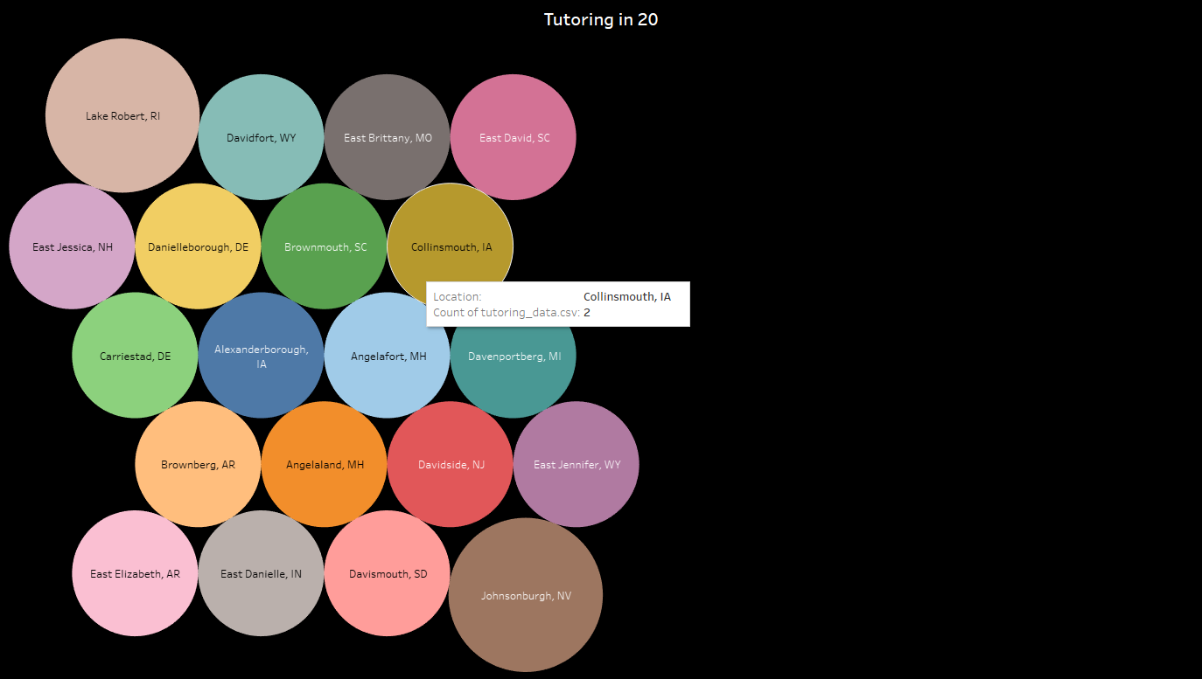

• The slide presents a bubble chart titled "Tutoring in 20" showing tutoring counts across different locations.

• Each bubble represents a city, with the size of the bubble indicating the number of tutoring instances.

• Locations like Lake Robert, RI have larger bubbles, suggesting higher tutoring activity.

• The bubbles are color-coded, making it easier to distinguish between different cities.

• A tooltip appears when hovering over a bubble, providing specific details like the city name and count.

DASHBOARD

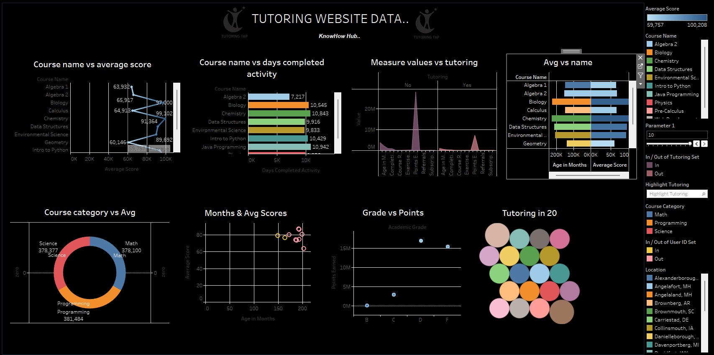

CONCLUSION

The tutoring website data shows that tutoring activity is spread across multiple cities, with certain locations like Lake Robert, RI leading in demand. The visualization highlights regional variations, suggesting opportunities to expand tutoring services in areas with lower activity and to strengthen offerings where engagement is already high.